Practical No. 1
Definition : Write a program to demonstrate basic input and output operations in Python.
Aim/ Objective:
- To understand how to accept input from the user in Python.
- To display output using the print() function.
- To perform basic operations on user-provided data.
- To understand basic Python syntax for input and output.
Source Code:
a = int(input("enter the first number"))
b = int(input("enter the second number"))
sum=a+b
print("final answer is :",sum)

output
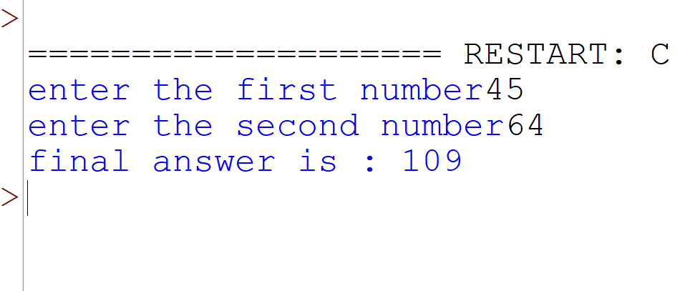
Conclusion:
The program successfully demonstrates the basic input and output operations in Python. It shows how to accept data from the user using input(), convert input into appropriate data types, store values in variables, perform a basic arithmetic operation, and display the results using print()

Definition : Write a program to illustrate the use of different
data types and type casting.
Aim/ Objective: To understand different data types in Python and demonstrate type casting between different data types.
name ="Vishw"
age = 20
height = 5.1
student = True

print(type(name))
print(type(age))
print(type(height))
print(type(student))

a=10
b=float(a)
print(a,"->",b)

c=10.99
d=int(c)
print(c,"->",d)

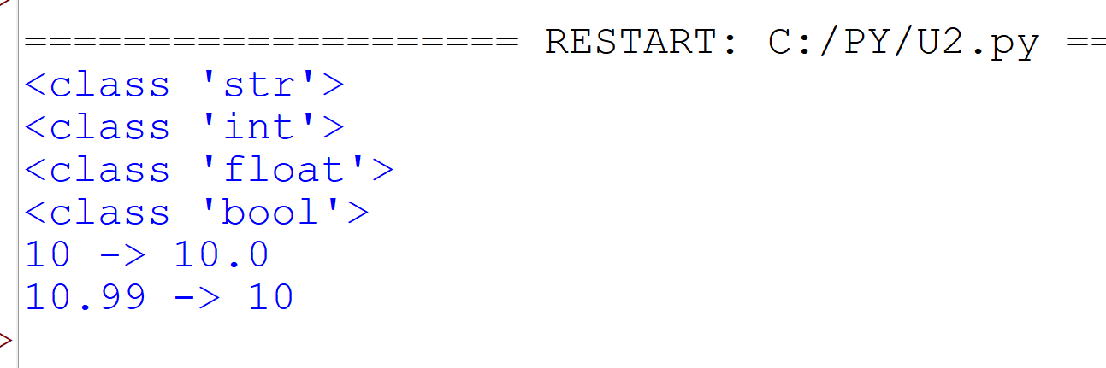

Conclusion:
Thus, the program successfully demonstrated different Python data types and conversion of values from one data type to another using type casting.
Definition : Write a program to perform arithmetic arithmetic relations and logical opretions using python oprators
Aim/ Objective: To understand and perform arithmetic, relational, and logical operations using Python operators.
Source Code:
a = int(input("enter the first number"))
b = int(input("enter the second number"))
add=a+b
sub=a-b
mul=a*b
div=a/b

print("addition answer is :",add)
print("substraction answer is :",sub)
print("multiplication answer is :",mul)
print("division answer is :",div)

print("the ans is equl",a==b)
print("the ans is not equl",a!=b)
print("the a is less then b",a<b)
print("the a is grater then b",a>b)
print("the a is less then equal b",a<=b)
print("the a is grater then equal b",a>=b)

Output:

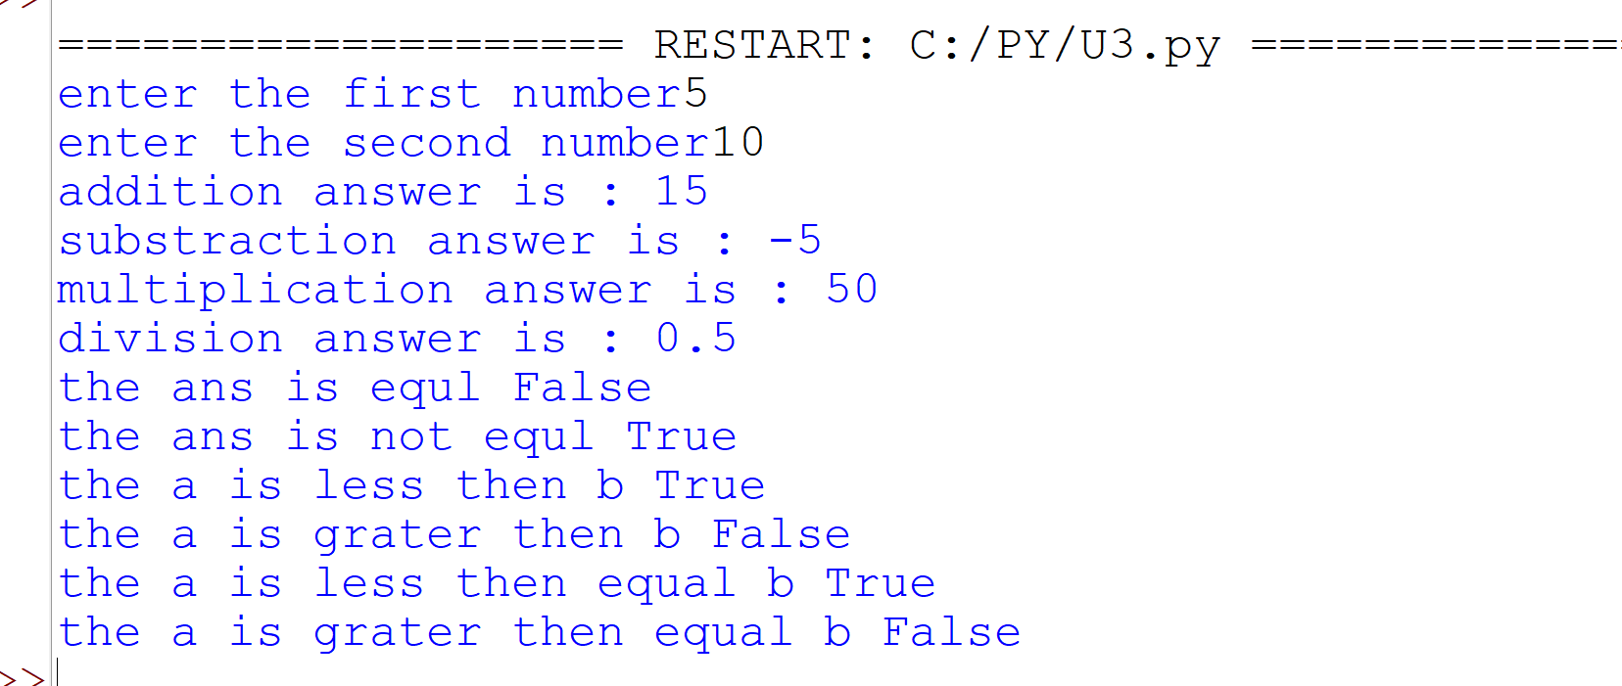

Conclusion:
Thus, the program successfully demonstrated arithmetic, relational, and logical operators used to perform different operations and comparisons in Python.

Definition : Write a program to demonstrate string operations including slicing formatting and built-in string functions.
Aim/ Objective: To understand and demonstrate string operations such as slicing, formatting, and built-in string functions in Python.
Source Code:
text = "welcome to the jungle"

print("slice the string",text[1:5])
print("Last 5 characters :", text[-5:])
print("string upper",text.upper())
print("string lower",text.lower())
print("string alphabetic",text.isalpha())
print("string digit",text.isdigit())
print("string split",text.split())
print("string alphabetic",len(text))

Output:
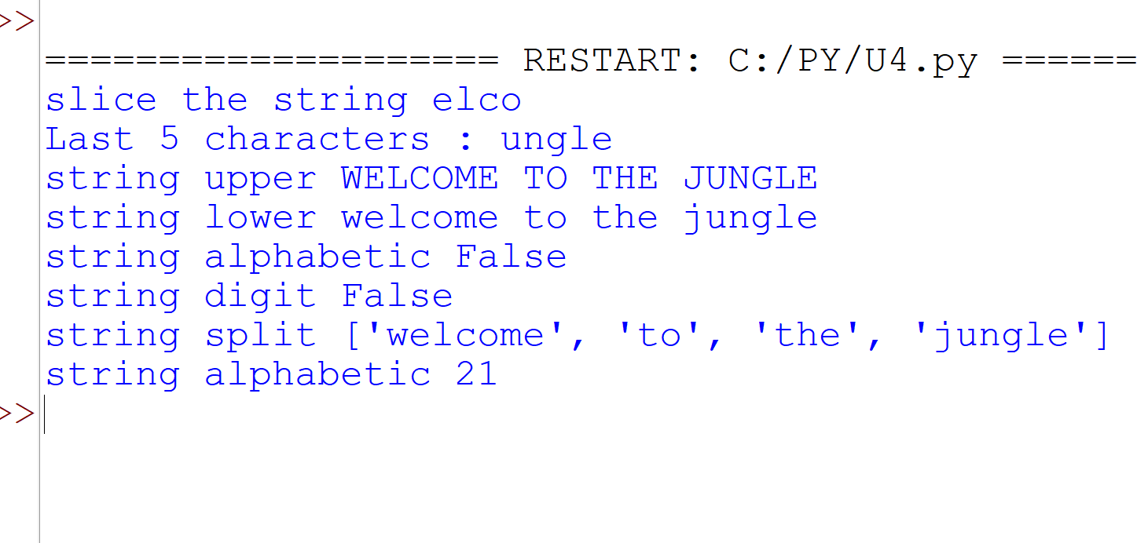

Conclusion:
Thus, the program successfully demonstrated string slicing, formatting, and various built-in string functions in Python.

Definition : Write a program to create and manipulate lists using indexing slicing and list comprehensions.
Aim/ Objective: To create and manipulate lists using indexing, slicing, and list comprehensions in Python.
Source Code:
list = [10,30,20,40,60,50,70,90]

print("enter the first element",list[0])
print("enter the third element",list[2])
print("enter the last element",list[-1])

list.append(90)
print("appended",list)

list.insert(1,50)
print("after inserted",list)

list.remove(20)
print("after removing",list)

squere = [x**2 for x in list]
print(squere)

even_numbers = [x for x in list if x % 2 == 0]
print("Even numbers:", even_numbers)

Output:
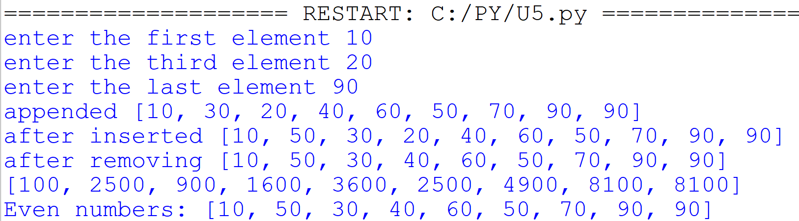

Conclusion:
Thus, the program successfully demonstrated the creation and manipulation of lists using indexing, slicing, list methods, and list comprehensions.
Definition : Write a program to illustrate the use of tuples and sets with basic operations.
Aim/ Objective: To understand tuples and sets and perform their basic operations in Python.
Source Code:
t = (10, 20, 30, 40)
print("Tuple:", t)
print("First element:", t[0])
print("Length:", len(t))
s = {10, 20, 30}
print("Set:", s)
s.add(40)
print("After adding:", s)
s.remove(20)
print("After removing:", s)
output :
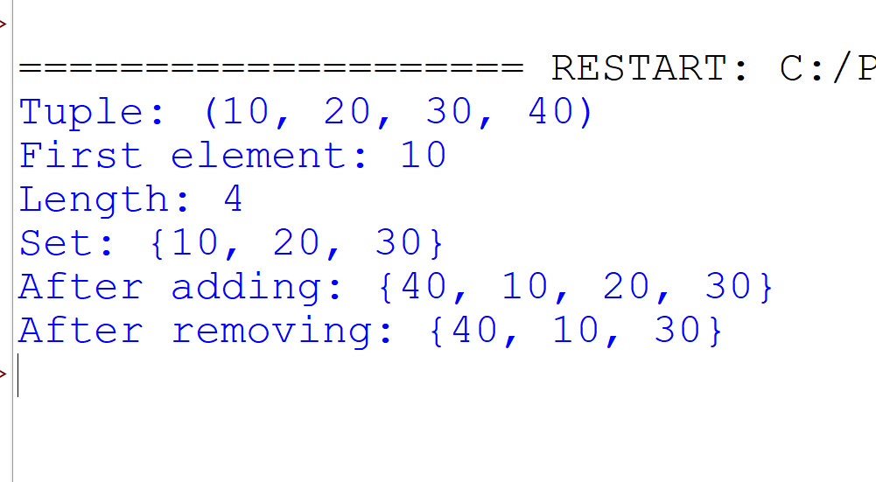
Conclusion:
Thus, the program successfully demonstrated tuples and sets along with their basic operations such as indexing, slicing, union, intersection, and difference.
Definition : Write a program to create a dictionary and demonstrate dictionary methods and iteration.
Aim/ Objective: To create a dictionary and demonstrate dictionary methods and iteration in Python.
Source Code:
student = {
"name": "Vishw",
"age": 20,
"marks": 100
}
print(student)
print("Name:", student["name"])
print("Keys:", student.keys())
print("Values:", student.values())
student["city"] = "Rajkot"
print("Updated dictionary:", student)
for key in student:
print(key, ":", student[key])
output :
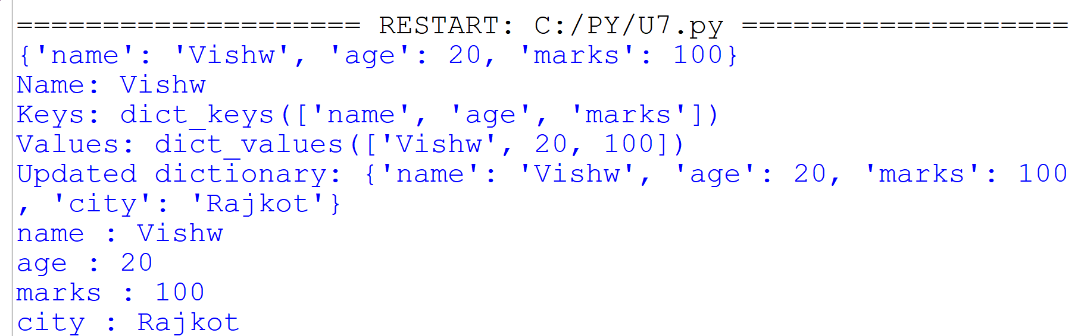
Conclusion:
Thus, the program successfully demonstrated the creation, manipulation, and iteration of dictionaries using various built-in dictionary methods.

Definition : Write a program to explain mutable and immutable objects in Python.
Aim/ Objective: To understand the difference between mutable and immutable objects in Python with suitable examples.
Source Code:
list1 = [10, 20, 30]
print("Before:", list1)
list1[0] = 100
print("After:", list1)
tuple1 = (10, 20, 30)
print("Tuple:", tuple1)
print("Tuple cannot be changed because it is immutable.")
output :
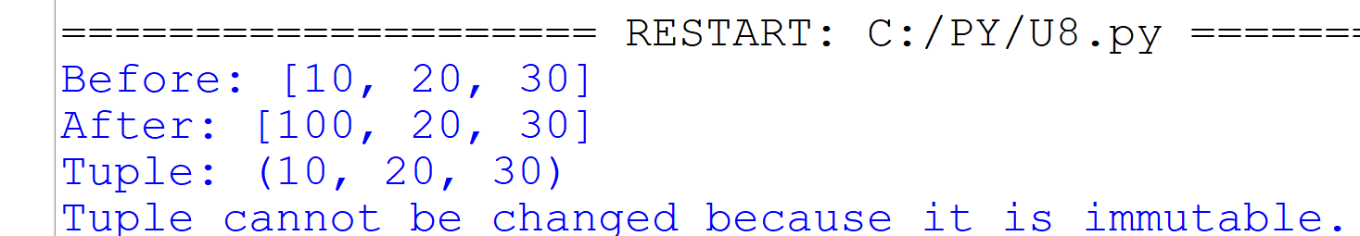
Conclusion:
Thus, the program successfully demonstrated the difference between mutable and immutable objects in Python with suitable examples of lists, tuples, and strings.
Definition : Write a program to define and use user-defined functions with different types of arguments.
Aim/ Objective: To define and use user-defined functions with different types of arguments in Python.
Source Code:
def hello():
print("Hello Python")
def add(a, b):
print("Addition:", a + b)
def square(n):
return n * n
hello()
add(10, 20)
x = square(5)
print("Square:", x)

output :
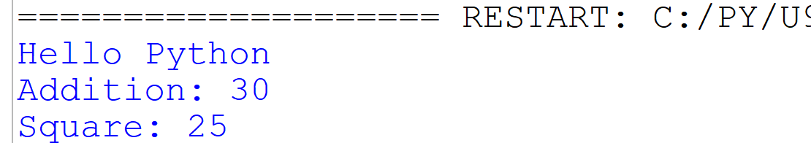
Conclusion:
Thus, the program successfully demonstrated how to define and use user-defined functions with different types of arguments, including positional, default, keyword, and variable-length arguments.
Definition : Write a program to demonstrate recursion using factorial or Fibonacci series.
Aim/ Objective: To understand and demonstrate recursion in Python by creating a recursive function to calculate the factorial of a number.
Source Code:
def factorial(n):
if n == 1:
return 1
else:
return n * factorial(n - 1)
num = int(input("Enter number: "))
print("Factorial:", factorial(num))
output :
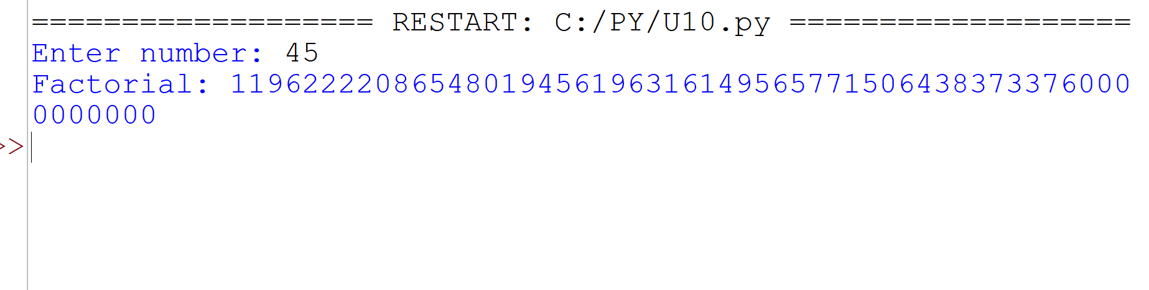
Conclusion:
Thus, the program successfully demonstrated the concept of recursion by using a recursive function to calculate the factorial of a number.

